CMPS 3600
Medel Antonio
Lab 02

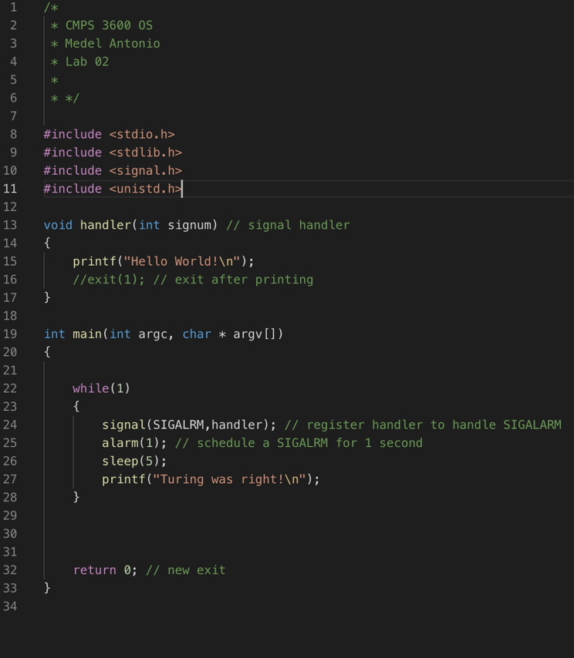
Caption 1 Here is the signal_base.c that runs infinitely
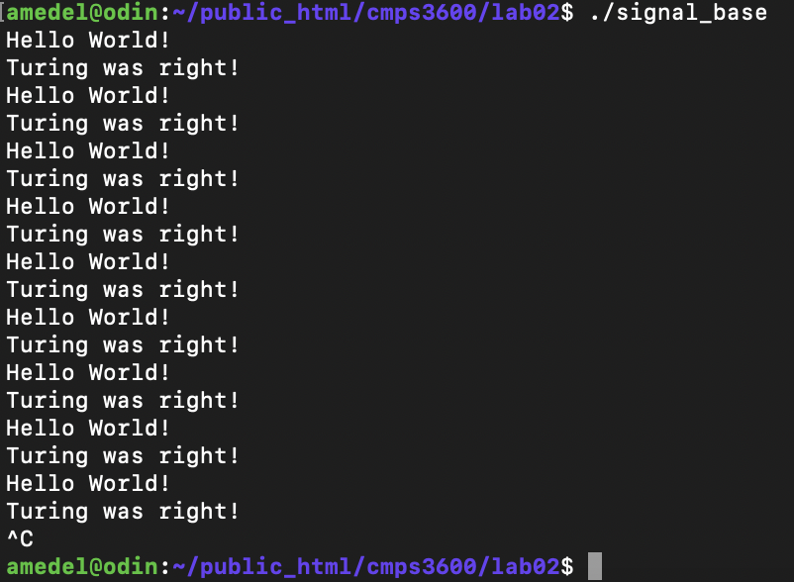
Caption 2 Here is the output of the signal_case.c that runs indefinitely
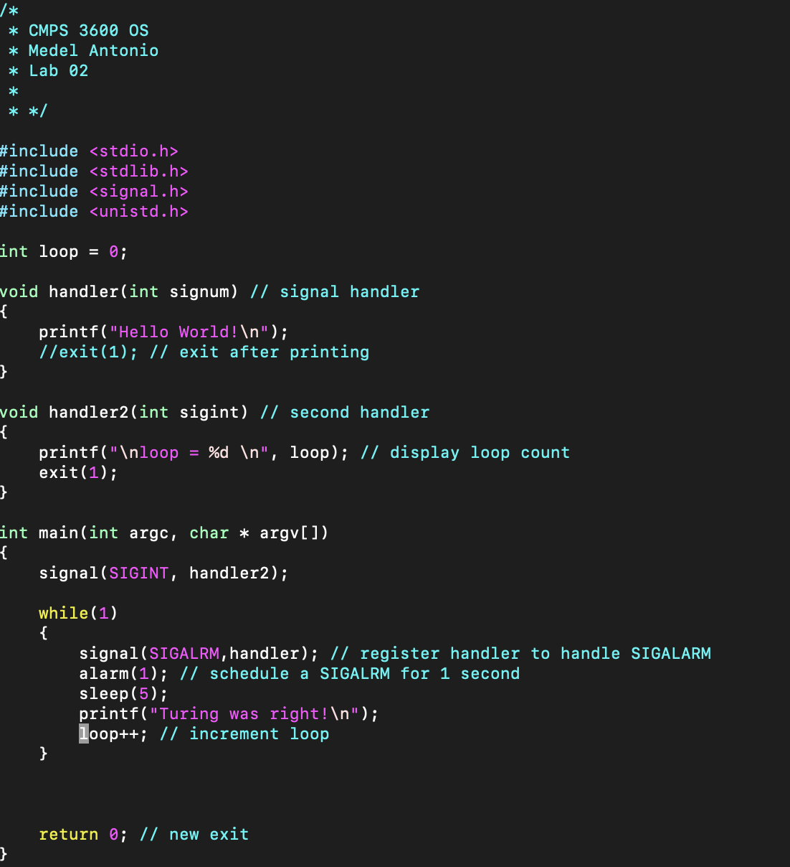
Caption 3 Here is the signal_base.c that runs indefinitely and checks for the SIGINT signal (check for CTRL-C ) to call handler2 and print the loop counter.
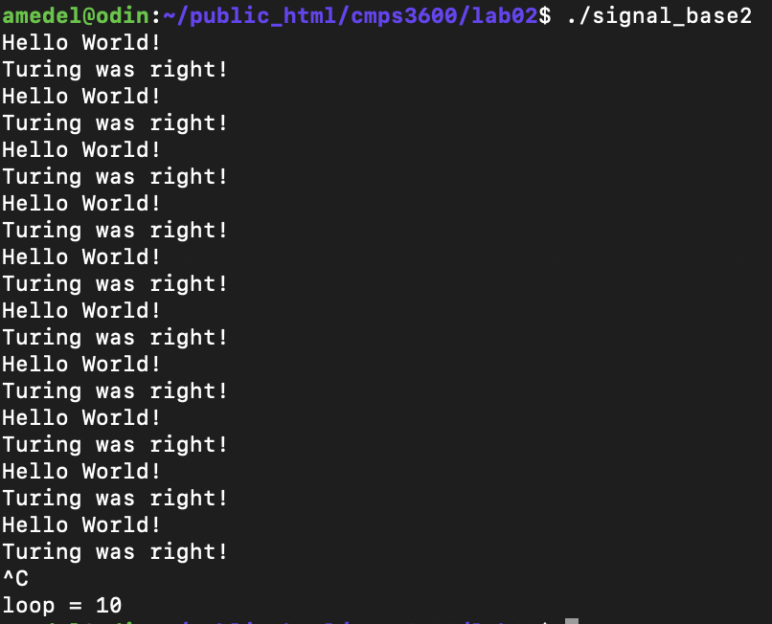
Caption 4 Output of signal_base.c that runs indefinitely AND has a check for CTRL-C to print loop counter.
In conclusion, I created two programs that run indefinitely and print something in response to a signal. signal_base or Medel_Antonio_Lab02-1 is just an infinite loop. signal_base2 or Medel_Antonio_Lab02-2 responds to a user signal (CTRL-C) and prints the loop counter after receiving that signal. I think seeing a program respond to user input better showed me what signals are and can do.

