CMPS 3620
Yang, Jonathan
Lab 01
Command Line Networking Tools

1. For this Lab assignment, the tools DIG, PING, TRACEROUTE, TRACEPATH, TELNET, NSLOOKUP, and NETSTAT were tested. DIG and NSLOOKUP seemed to provide the most useful information regarding information about the server, while PING, TRACEROUTE/TRACEPATH, and NETSTAT provided information about how well the connection between the client and server is operating. TELNET seems to have more utility if one is able to connect to the host directly. All of the tools were able to work on both google.com and cs.csub.edu.
====================================================================================
2.
Output for dig www.cs.csub.edu
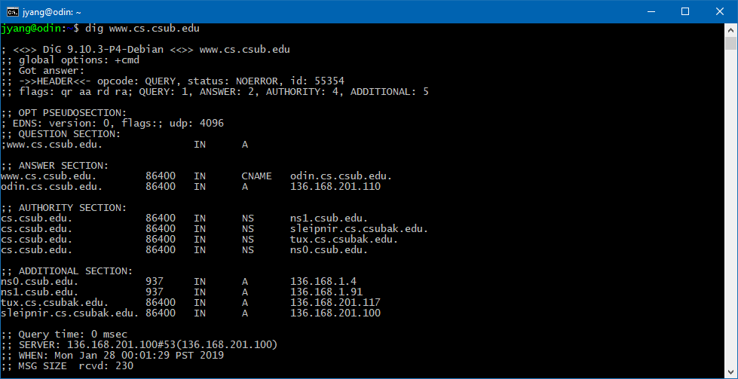

Output for dig soa www.cs.csub.edu
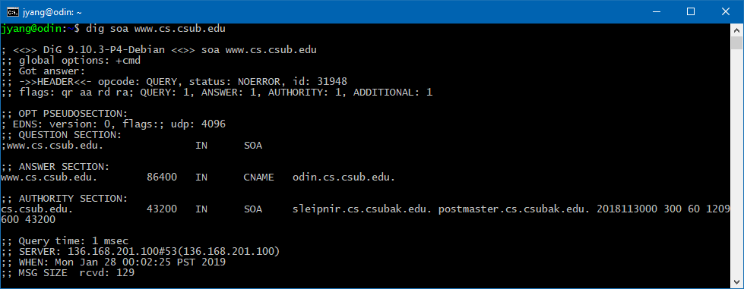

The difference between the two commands can be found in the AUTHORITY SECTION of the two outputs. With ‘soa’ included as a tag, the tool reveals the Start of Authority record including the primary name server (sleipnir.cs.csubak.edu), the responsible party (postmaster.cs.csubak.edu), and the time that the domain was last updated.

==================================================================================
3. The command dig soa 224.9.209.in-addr.arpa will find the Start of Authority record. In-addr.arpa is used to determine which IP address is associated with a host name through reverse mapping the inverse address.

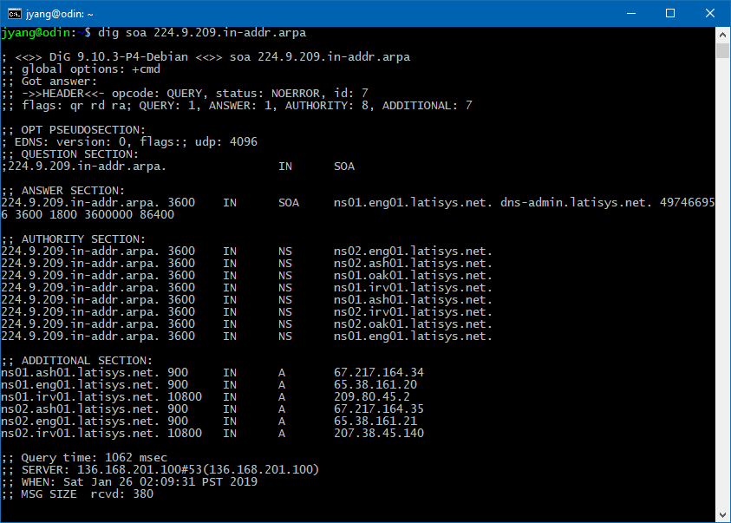

==================================================================================
4. If the error message includes --- unknown host ---, the likely problem is that while trying to PING ftp.foo.com, the host server does not have their DNS properly configured. This could be investigated with the NSLOOKUP command in order to test the host name resolution and check DNS server registration
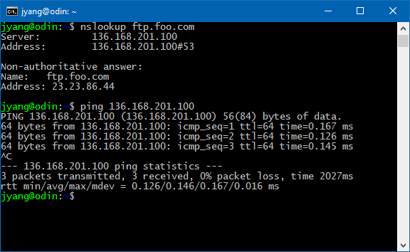
================================================================================
5. If the error message includes ‘… Connection timed out’, a connection possibly via TELNET, SSH, or TELNET was not able to be formed. This could be an error caused by the host server being down or not existing at that domain and could be also checked by NSLOOKUP to check if the domain exists or is down.
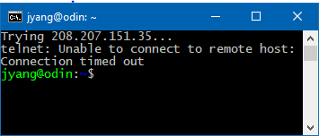
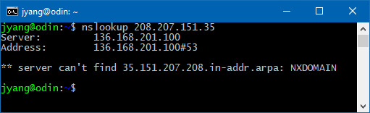
Conclusion:
DIG is clearly the most versatile tool of those used, while PING and NSLOOKUP provide very quick valuable information. The importance of TRACEROUTE/TRACEPATH and NETSTAT is not yet known to me yet, but I am sure it will be heavily used in the future due to the large stream of data to be had with those searches.

=================================================================================
ADDITIONAL SCREENSHOTS OF COMMANDS
DIG
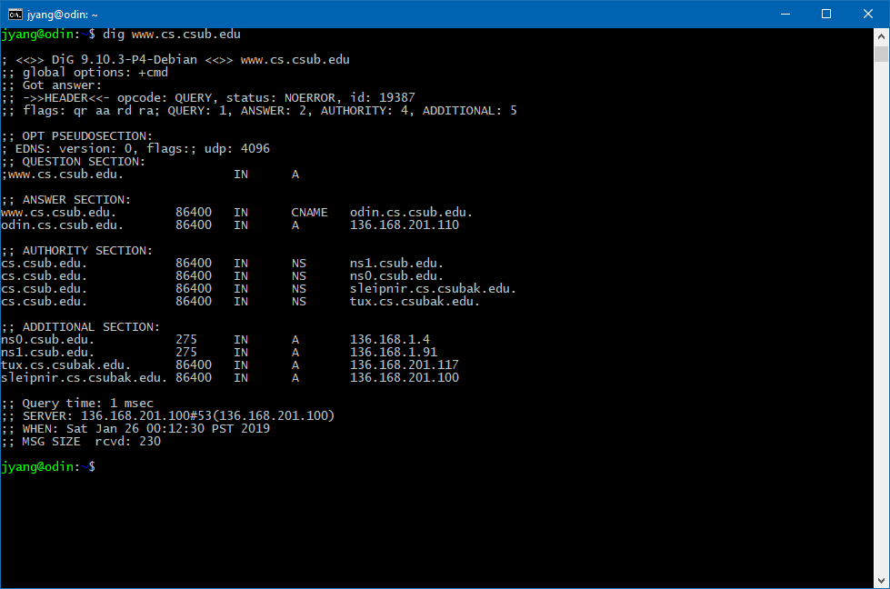
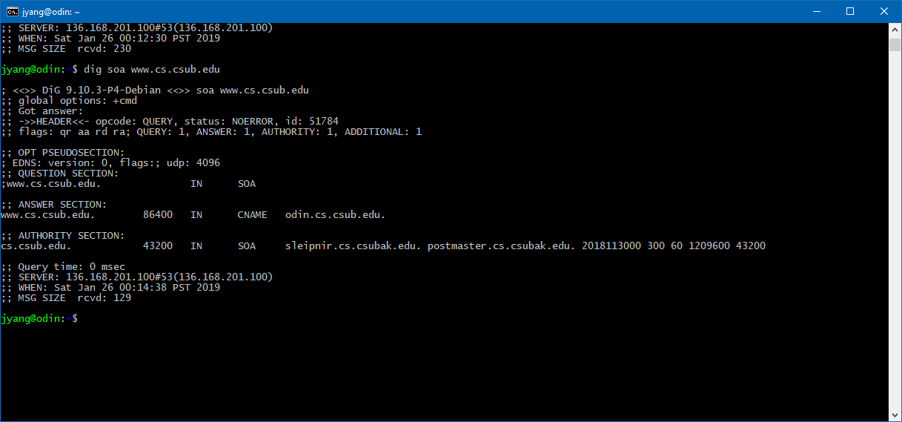

PING
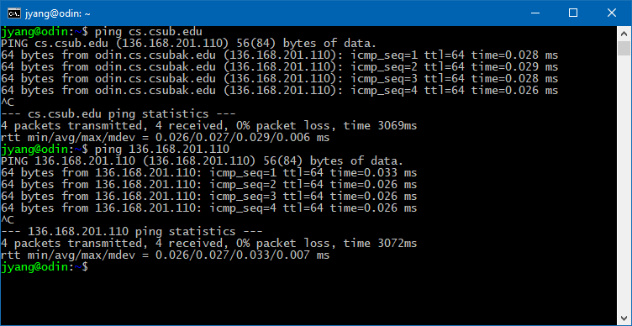
TRACEROUTE
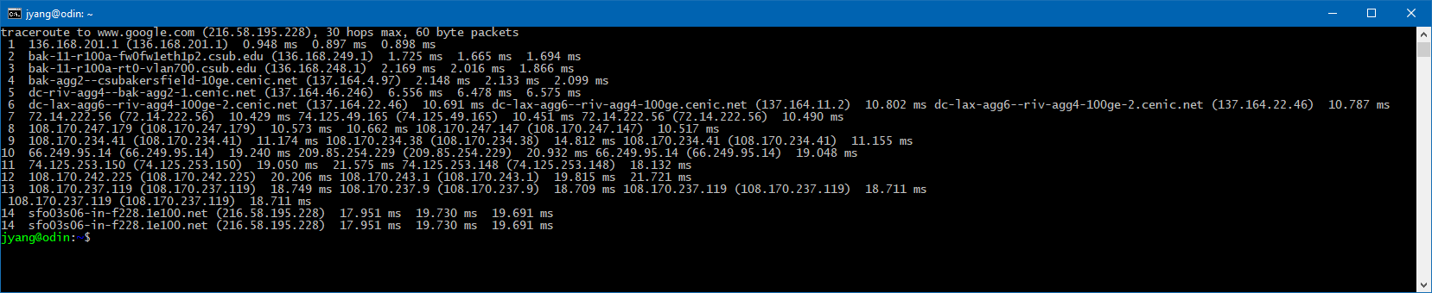
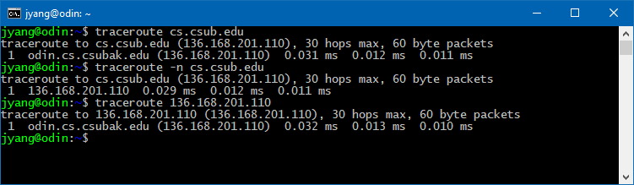
TRACEPATH
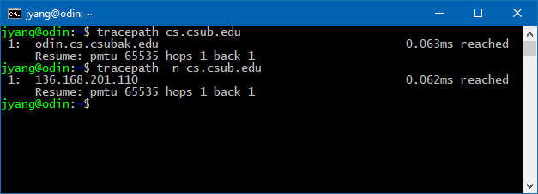
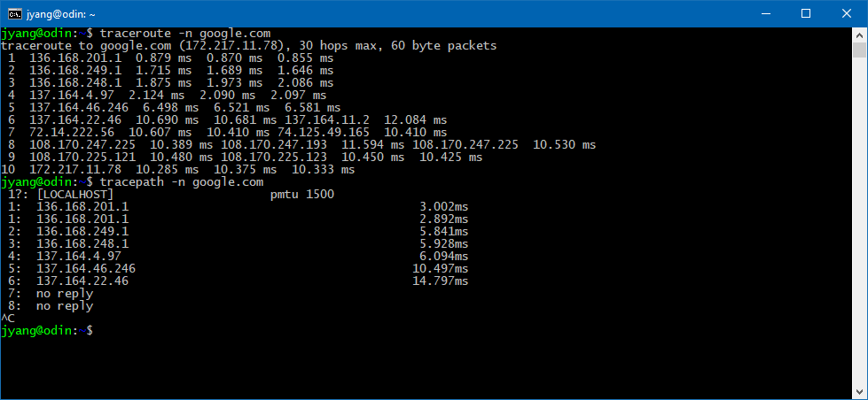

TELNET
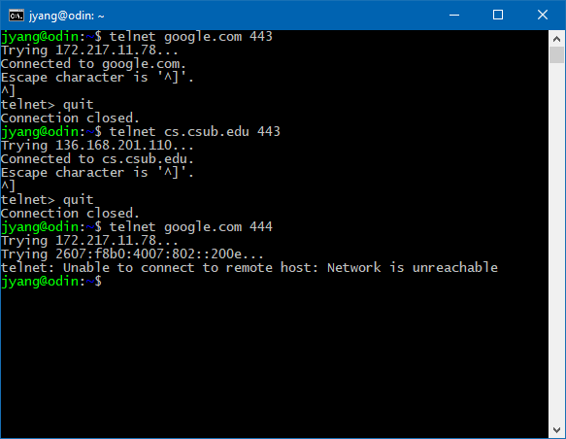
NSLOOKUP
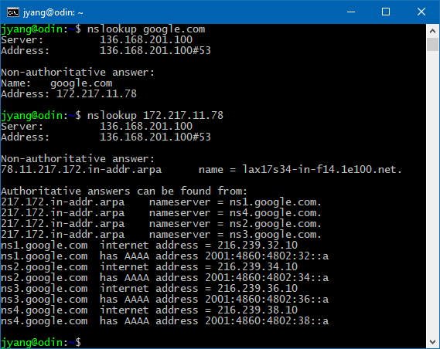
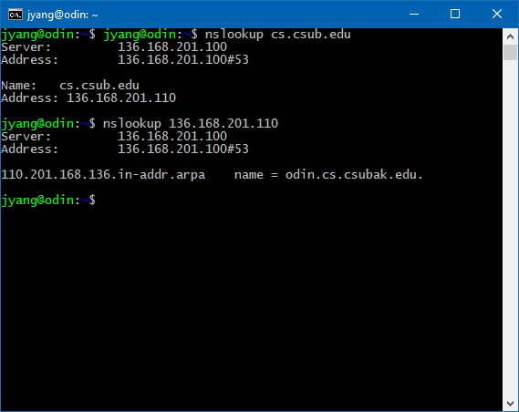

NETSTAT
